Databases for Data Analytics
Task 3 — Joins and DML | Yaron Besser
Question 1
Task: All movies with a role 'himself' or 'herself' (case insensitive); multi-role movies counted once.
Row count: 23,525
SQL Query:
SELECT DISTINCT
`name`, id, year
FROM
movies AS m
JOIN
roles AS r ON m.id = r.movie_id
WHERE
LOWER(`role`) IN ('himself', 'herself')
ORDER BY id;
Result:
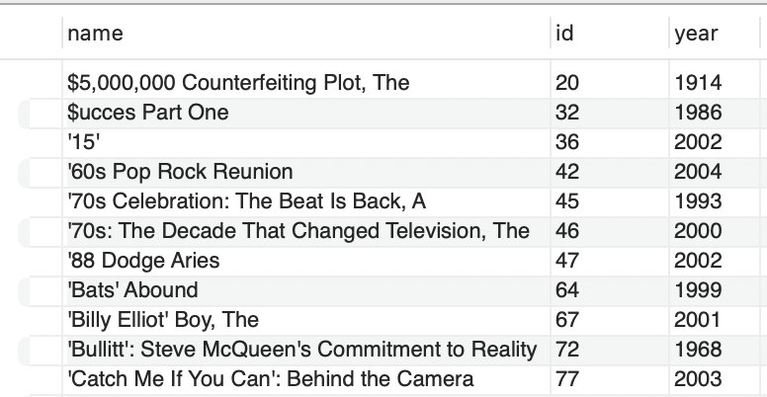
Explanation:
Joined movies with roles on movie_id, filtered LOWER(role) to 'himself'/'herself' for case-insensitivity, and used DISTINCT so a movie with multiple self-roles is counted once.

Question 2
Task: All actors that Alfred Hitchcock directed.
Row count: 1,342
SQL Query:
SELECT DISTINCT
a.first_name, a.last_name, a.id
FROM
directors AS d
JOIN
movies_directors AS md ON d.id = md.director_id
JOIN
roles AS r ON md.movie_id = r.movie_id
JOIN
actors AS a ON r.actor_id = a.id
WHERE
d.first_name = 'Alfred (I)'
AND d.last_name = 'Hitchcock'
ORDER BY a.id;
Result:
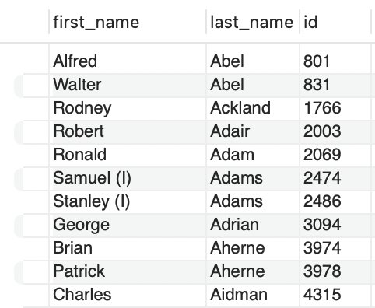
Explanation:
Chained four joins (directors → movies_directors → roles → actors) to link Hitchcock to the actors who appeared in his movies. Filtered on his exact name 'Alfred (I) Hitchcock' and used DISTINCT since an actor may appear in several of his films.

Question 3
Task: All genres in which Hitchcock did not direct any movie. Improve lookup performance by creating a dedicated genres table.
Row count: 7 (out of 21 total genres in genres_type)
SQL Query:
-- Creating a dedicated table for genres
DROP TABLE IF EXISTS genres_type;
CREATE TABLE genres_type AS
SELECT DISTINCT genre FROM movies_genres;

-- All genres in which Hitchcock did not direct any movie
SELECT gt.genre
FROM genres_type AS gt
LEFT JOIN (
SELECT mg.genre AS hitc_genre, d.id
FROM directors AS d
JOIN movies_directors AS md ON d.id = md.director_id
JOIN movies_genres AS mg ON md.movie_id = mg.movie_id
WHERE d.first_name = 'Alfred (I)'
AND d.last_name = 'Hitchcock'
) AS hitc ON gt.genre = hitc.hitc_genre
WHERE hitc.id IS NULL;
Result:
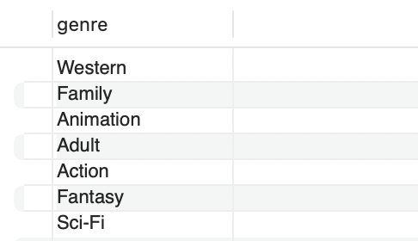
Explanation:
Built a dedicated genres_type table holding each genre once (21 rows). Used a LEFT JOIN against a subquery containing every genre Hitchcock directed in; rows with no match get NULL on the right side, so WHERE hitc.id IS NULL returns exactly the 7 genres he never worked in — an anti-join, equivalent to NOT IN. Why pull d.id into the subquery: d.id is the primary key of directors, so it is guaranteed NOT NULL on every matched row. That makes hitc.id IS NULL a reliable anti-join signal — a NULL there can only mean 'no match from the LEFT JOIN', never a genuine missing value. Checking a nullable column instead would risk false positives.

Question 4
Task: Copy movies to sad_movies and delete all that belong to the genre 'Comedy'.
Row count: 331,844 remaining in sad_movies (388,269 − 56,425 deleted)
SQL Query:
-- Copy movies into sad_movies
DROP TABLE IF EXISTS sad_movies;
CREATE TABLE sad_movies AS
SELECT id, `name` FROM movies;

-- Delete all that belong to the genre 'Comedy'
DELETE sm FROM sad_movies AS sm
JOIN (
SELECT id
FROM movies AS m
JOIN movies_genres AS mg ON m.id = mg.movie_id
WHERE mg.genre = 'Comedy'
) AS com_movies ON sm.id = com_movies.id;

-- Testing: should return 0 rows (no Comedy left in sad_movies)
SELECT *
FROM sad_movies AS sm
JOIN movies_genres AS mg ON mg.movie_id = sm.id
WHERE genre = 'Comedy';
Result:
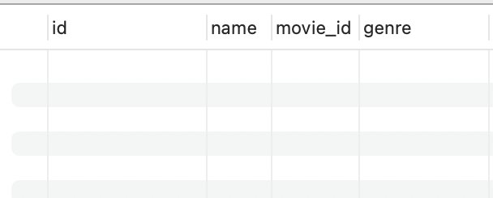
Explanation:
Copied movies into sad_movies with CREATE TABLE AS SELECT, then used DELETE ... JOIN against a subquery of Comedy movie ids — the inner join keeps only Comedy rows and DELETE removes them. Result: 56,425 Comedy movies deleted, 331,844 non-Comedy remain (388,269 − 56,425). The test query returns 0 rows, confirming no Comedy survived.

